**2**

**Design of lattice towers**

**2.1. General Principles**

In this chapter, the design verifications carried by the software are detailed including design assumptions required to develop a program with a high level of automation.

The software was developed to design lattice steel towers with angle sections according to BS EN 50341-1. Resistance checks are done according to EN 1993-1-1 (EC3-1-1) and stability calculations follow the annex G and H of the EN 1993-3-1 (EC3-3-1).

According to clause 7.3.5 of EN 50341-1, the tower should be checked with a global elastic analysis, the model is usually pin jointed but if the continuity between members is considered the bending moments can be neglected.

The code identifies three types of elements: leg members, bracing and secondary bracing elements. As the secondary bracing elements – also called redundant members – do not receive direct loads and are in place just to assure local stability of the load bearing members, they can be ignored in the global analysis.

Sections are classified according to EC3 and when class 4 the effective area should be used in the design verifications. The effective area is calculated according to EC3 unless the sections are hot rolled angles, for that case clause 7.3.6.2 of EN 50341-1 provides the following expressions to calculate the effective area:

Deformations and vibrations under SLS loads and fatigue are not normally considered unless specified on the project.

**2.2. Design Loads**

Lattice tower structures, as any type of structure, are subject to various loads during their life time. The present work will not go into detail on every combination, instead the critical loads will be presented along with other relevant information provided by Metalogalva.

Lattice towers used on energy transmission lines have their design loads defined according to BS EN 50341, along with the self-weight of the structure itself, the tower must be able to withstand the loads applied by the cables.

The actions of the cables are applied to the structure as a point load at the end of each arm, the critical loads when designing this type of structure are:

* Self-weight of the cables
* Wind loads on the cables
* Force from change of direction on the transmission line (in angle towers)
* Force due to cable failure
* Anchorage force on terminal towers

Seismic and fire actions are usually not considered unless specified by the client. Wind loads in the structure are also taken into account when designing these types of structures. According to BS EN 50341, the bending moments created by this action on individual elements can be ignored. Wind loads are usually critical for steel poles (figure 2.1), however that is not observed in lattice structures (fig 2.2), due to its shape, normally wind loads add just 10% more stresses on the structural elements.

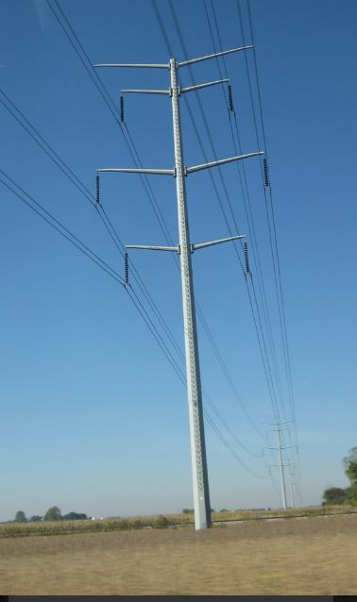 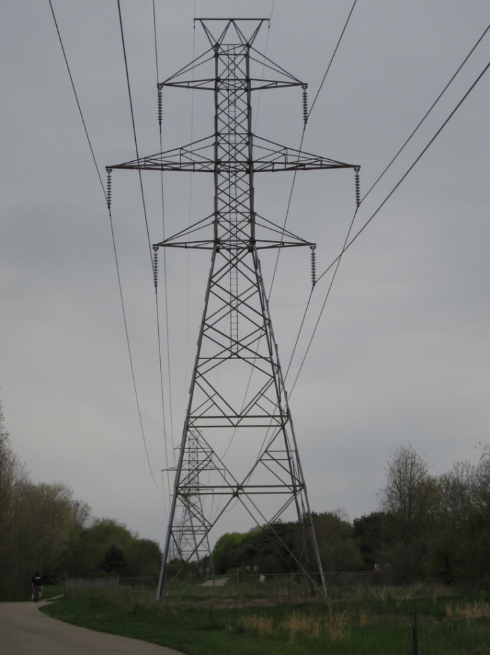

Fig. 2.1 – Steel Poles Fig. 2.2 – Lattice tower

**2.3. Resistance Verification**

For this type of structure, the members should be checked according to EC3. There is a provision regarding angles connected through one leg, since the software outputs a structure where the connections are not yet designed this verification is not implemented in the final program.

The software uses the Eurocode 3 checks for both tension and compression elements, as the structure is pin jointed only axial loads are considered on the verification and the area used is the value received by the user, the expression used is:

**2.4. Stability Verification**

Buckling resistance of members in compression was checked using annex G and H of EC3.

The expression used to determine the buckling resistance (Nb,rd) of a member is available on Part 1 of the EC3:

The steps needed to determine the reduction factor χ and factor Φ are detailed in Annex G of the EC3. A new effective slenderness ratio,, should be used to calculate both factors, this new slenderness ratio is determined by multiplying the original slenderness ratio (from Eurocode 3) by a factor K that varies with the member being calculated (leg , diagonal or horizontal bracing member).

To determine , Annex H is used to get the buckling length relevant to the member and is calculated according to EC3 part 1.

The effective slenderness factor, K, is calculated from the expressions on tables G.1 to G.3 from the Eurocode 3 that list various values depending on the section type, buckling axis, geometry and member type.

2.4.1. Effective Slenderness Factor - K

For Leg members table G.1 is used, as the software is intended to design only with single angle elements and given the characteristics of the base structure (detailed in chapter 4), geometry of the type described as case (d) on table G.1 is not possible, as such, the expression used to calculate the effective slenderness factor, K, is given by:

Even though case (d) – “discontinuous top end with horizontals” – is not allowed as a possible solution case (e) is possible. This case uses the same expression to determine the effective slenderness factor, K, according to another axis, y-y. As the algorithm does not know if the structural solution is symmetrical or unsymmetrical there is a function (detailed in chapter 4) that builds the internal analytical model (IAM) and states the axis in which stability checks need to be carried on Leg members.

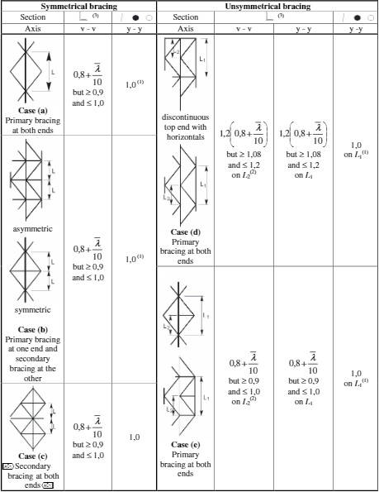

Fig. 2.3 – EC3 table G.1 from Annex G

For diagonal bracing, annex G states that “k should be determined taking into account both bracing pattern and the connections of the bracing legs. In the absence of more accurate values, k should be obtained from table G.2”. In a genetic algorithm that automatically iterates through various topologies it is not possible to analyse, without significant computation, the spatial relationship between all the members in each plane with sufficient detail to determine a bracing pattern, in fact it is highly likely that some solutions of the GA do not fit a predefined bracing pattern listed in annex H. Having this into account the “worst case” was adopted and as stated on annex G the k value was obtained from table G.2.

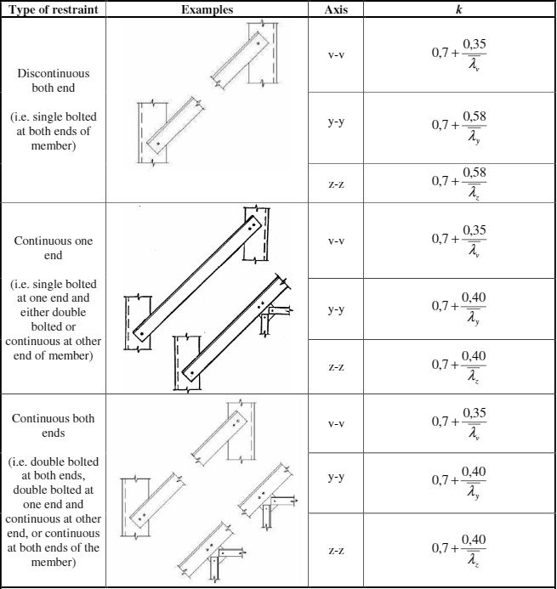

Fig. 2.4 – EC3 Table G.2 from Annex G

To extract values for K from table G.2, additional information regarding connection types for bracing members is needed, as previously stated software developed for this thesis is intended to be used in the definition of the tower geometry, as such the connection types are not yet known, in this case an option was made to work with the expressions for the worst-case scenario – higher k values – where bracing members are discontinuous and single bolted at both ends.

Horizontal bracing members have the same rules of diagonal members with the exception of K bracing patterns where the K value needs to be reduced by a ratio determined from table G.3 to account for a member with both tension and compression in each half of its length.

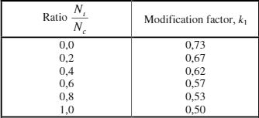

Fig. 2.5 – EC3 Table G.3 from Annex G

2.4.2. Buckling Length

To determine the buckling length of the members, EC3 does the same distinction between leg, diagonal and horizontal bracing members annex H details the steps to take for each type of element.

For leg members, as the algorithm was developed for regular towers where single angle sections where used for the bars and perpendicular truss planes, clause 2 for H.2 is met and the buckling length for leg members is the distance between two nodes. Given the type of FE model used there is a possibility that an element in the final structure is made of several bar elements in the finite element model, to take this detail into account an auxiliary algorithm was used to create the internal analytical model (IAM) that assembles several bars into one when certain conditions are met. This algorithm is described in detail in Chapter 4.

Diagonal bracing elements are differentiated between primary and secondary elements, to develop a program that finds the best solution with minimal user interactions a trade-off was made: every bracing member starts as a primary bracing element. This requires secondary elements to be evaluated against the stricter criteria that primary elements must pass this obviously makes the sections larger than they have to be.

During testing on real towers, Metalogalva gave useful technical insight that limited the real-world cost of this trade-off. To make the connection design viable in practical terms there is a minimum section size that can be used, the L40x40x4, with this new practical limitation it became clear that even though the theoretical structure could be lighter the real structure – where connections must be designed – would have no significant weight added from this simplification.

Primary bracing elements have their slenderness calculated with the following expression:

The length, , is specified from figure H.1 from annex H.

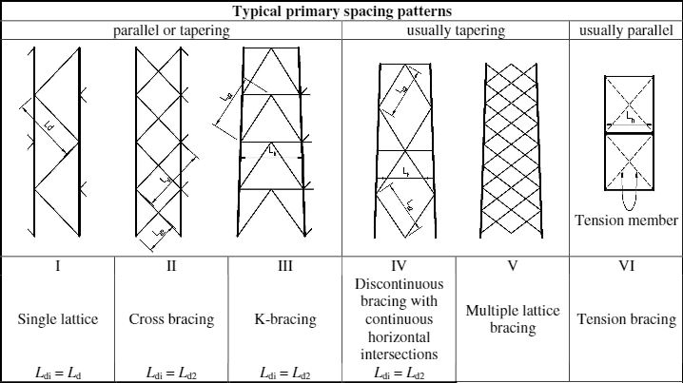

Fig. 2.6 – EC3 Figure H.1 from Annex H

As shown in figure 2.6, most buckling lengths are simply the distance between the start and end nodes of bars. There is an exception made for cross bracing, according to H.3.3(1): “Provided that the load is equally split into tension and compression, the members are connected where they cross, and provided also that both members are continuous, the centre of the cross can be considered a point of restraint (…)”. This point is accounted for not directly in the code tasked with generating the IAM but by allowing the user to set the number of horizontal divisions that the program will test.

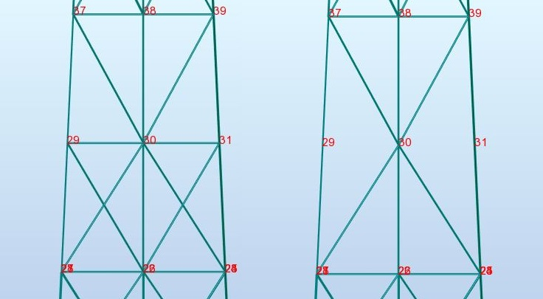

Fig. 2.7 – Increased number of horizontal divisions

As can seen in Figure 2.5, increasing the number of horizontal divisions has the same effect as considering the intersection point as a point of restraint, for example the buckling length of the top left diagonal bar remains constant (distance between node 37 – 30) with and without horizontal bars in place. With the evolution of the structure the added horizontal bars will eventually be deleted if the Genetic algorithm deems them unnecessary (as seen on the right of figure 2.7).

Horizontal bracing members need to be checked for buckling in the horizontal plane (transverse stability) and in the frame plane.

To ensure transverse stability for the horizontal members over a certain length, plane bracing should be provided. According to Figure H.3 from EC3 there are two types of plane bracing, triangulated and not fully triangulated.

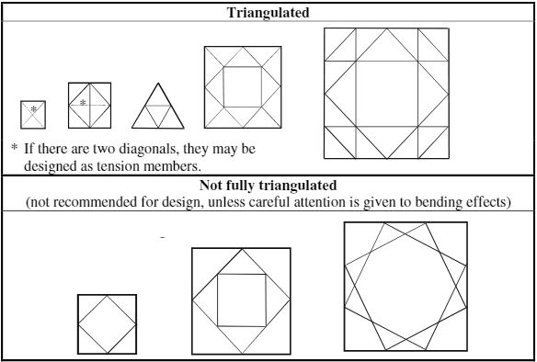

Fig. 2.8 – EC3 Figure H.3 from Annex H

The algorithm assumes every existing plane bracing to be fully triangulated as it is usually the solution that allows for more material savings in the horizontal bracing members (smaller buckling length). As shown in Figure 2.6 there are several triangulation solutions depending on the degree of subdivision of each side of the tower. Each type of plane bracing would need to be hard coded in the initial structure definition as a function of the subdivision of the tower, although possible, this definition of geometry for each subdivision type would take away too much development time (hard coding several plan bracing geometries) for the objective of the present work, instead an alternative method was found that defined the initial triangulation solution and relied on the user to complete the triangulation. This will obviously be corrected in an eventual commercial spin-off of this application.

According to Annex H of EC3-1-3, the buckling length for transverse stability when there is a need for plane bracing is the distance between intersection points of the horizontal bracing members with the plane bracing members. When the length is sufficiently small to delete plane bracing the buckling length for single angle members is described in H.3.10 (2) and supported by figure H.4.

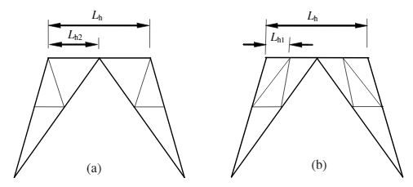

Fig. 2.9 – EC3 Figure H.4 from Annex H

The length is either half of the total length,, or the distance between intersection points with leg or diagonal bracing members, .

For stability verification in the plane frame the buckling length is the distance between intersection points with leg or diagonal bracing members in that plane frame. Figure H.3.9 (3) of EC3-3-1 indicates that, when there is bracing at or near the mid-point of the horizontal bracing members it is possible to use the less restrictive rectangular radius of gyration for the stability verification, when that is not the case the v-v radius of gyration, ivv, should be used. Given the nature of the algorithm it is not known from the start if the structure has bracing members close to the centre, however, tests with several tower sizes have shown that with sufficient initial subdivision levels the probability of horizontal members having no restraint near the centre is very low.

To analyse which development path to take two versions of the same program were created, one using the rectangular gyration axis where allowed and the other using always the ivv. The final results, indicated that, the extra material savings that were to be expected from using the y-y axis were negligible. Most horizontal bars have their section limited by the minimum section required to allow realistic connections to be designed (as detailed previously). The only horizontal bars where savings were obtained were the horizontal bars near the arm elements, that means that the higher the tower, the more diluted this small weight gains become. Based on the results of this test the final version of the program uses the conservative ivv radius of gyration for the stability verification in the plane frame.

**2.5. Connection Design**

Connection design on this type of structures is done according to Part 1-8 of Eurocode 3. The software developed in this thesis is intended to support the engineer during the geometry definition of the tower. The engineer is then needed to define the connections between elements of the output geometry and sections. Even though not the objective of the developed application, it makes the job easier for the engineer by using a minimum section that ensures the connection design stage is completed without changes in the section sizes.